**CLIMATETREE**



**Developer Guide**

**Overview**

ClimateTree™ is an innovative project that empowers communities of all scales and types to find, share, and discuss climate change solutions using the latest in Geographic Information Systems (GIS), web-platform, and social media technologies.

**Intended Audience**

This developer guide is intended for users who wish to technically understand how ClimateTree site is developed, as well as wish to further extend the capabilities of ClimateTree

**Architecture diagram**

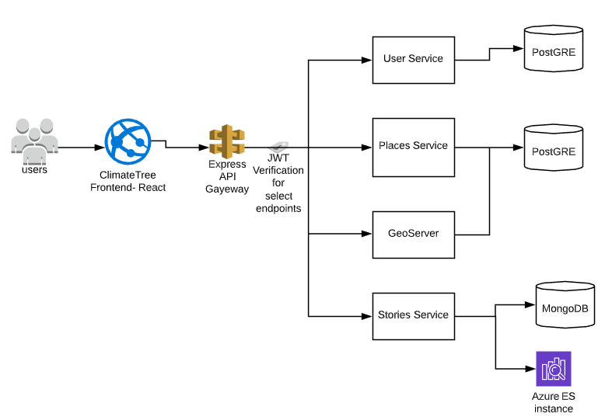

**Links to the Hosted Services**

Main Site Link (front-end): <http://www.climatetree.wiki>

GitHub Repo link: <https://github.com/climatetree>

GitHub Documentation link: <https://github.com/climatetree/docs>

Link to developer guides:

1. Frontend:
2. DevOps: <https://github.com/climatetree/docs/blob/master/Devops%20Documentation.pdf>
3. API Gateway:
4. User Microservice: <https://github.com/climatetree/docs/blob/master/User%20microservice%20Developer%20guide.pdf>
5. Stories Microservice:

<https://github.com/climatetree/docs/blob/master/Stories%20Microservice%20Developer%20Guide.pdf>

1. Places Microservice/ Geoserver: <https://places-postgres2.azurewebsites.net>

**Known issues and risks**

All the defects and future enhancements to this project are logged at the following link under “Climate Tree Defect Tracker” project. <https://github.com/orgs/climatetree/projects/1>